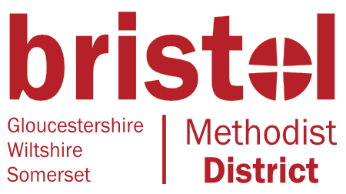
Eco District Newsletter
No 5 Winter 2021
Welcome to the winter edition of our newsletter. Happy New Year to everyone! This newsletter is produced by the District Eco Group which contains representation from most of the circuits and areas within the Bristol District. If your circuit is not represented please get in touch as we would love you to join us!
Congratulations to the churches which have achieved awards since the last newsletter: Longwell Green United Church LEP, Salem Watley’s End and Badminton Road (all bronze awards in Bristol and South Gloucestershire Circuit). If there have been other awards in your Circuit please let us know so that they can be celebrated here.
COP26 may be over, but it will continue to be vital for churches to build on the progress made last year. The Climate Sunday campaign is calling on churches to continue to deepen their understanding of creation care and climate justice, to continue to take action in their buildings and community for the environment, and to raise their voices to put pressure on the UK government to scale up and follow through on climate commitments made in Glasgow. They are organising a webinar on Thursday 20th January from 7pm to 8.30pm, chaired by Andy Atkins, CEO of A Rocha UK. For details and to register follow this link: https://www.climatesunday.org/climate-sunday-what-next-after-cop26
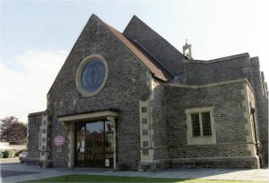
A Good News Story – United Church in Longwell Green, Bristol and South Gloucestershire Circuit – Bronze Eco Award
Rev. Mark Yan Ying Sum Nam, Curate at United Church Longwell Green writes:

A year ago, two members of our congregation—Carol Jones and Emma Jukes—began the online Eco-Church survey which helps churches measure how effective they are in their life and work at caring for God’s creation. I joined the Eco-Team six months ago and between us, we set short-term, mid-term and long-term goals for our church under each category. Most of the long-term goals were complex, requiring input from our ECC—particularly when considering ‘buildings’ and ‘land,’ which involve significant cost and planning.

Thankfully, the mid and short-term goals were easier to implement—many involving participation from members of our community. For example, getting young families to create bug-hotels and encouraging folk to sponsor a bird or bat box. Some were as easy as putting up signs reminding people to turn off the church lights or heaters when they were done. Rather movingly, a recently bereaved widower expressed a desire to donate a bench in memory of his late wife to encourage community-engagement with our wildlife garden.

As I reflect upon the impact that the Eco-Church survey has had on our church, what strikes me most is how it has brought us closer together as a community. It has drawn us around a common concern—a concern that is found at the heart of the Gospel—and it has helped us grow as a community through the pandemic.

On Nov 7th we hosted a Climate-Care Sunday in collaboration with a nearby Anglican Church called St. Anne’s, and a neighbouring independent church called The Mustard Tree. This was a great success, and the following day we received confirmation of our bronze award. Whilst I am grateful that we have achieved this award, I am most excited about the way it has raised awareness across our churches and fostered a shared sense of responsibility and concern for the world God has given us to share and live in.
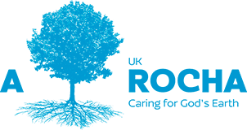
If you are looking for items for your church magazine or information about Eco Church to help with your church’s journey, why not subscribe to A Rocha’s eNews? It contains regular updates on environmental topics. You can find it using your favourite search engine or by this link: https://arocha.us14.list-manage.com/subscribe
2022: The Year of Nature? This month’s eNews from A Rocha contains an article by Andy Atkins, CEO of A Rocha UK pointing out that the biodiversity crisis will come to the fore this year. A big and early international nature ‘moment’ will be ‘COP15’ – the next meeting of the parties to the UN Convention on Biological Diversity. It will meet in Kunming, China, for two weeks in late April and early May and is tasked with setting new international goals to avoid mass extinction of species. Though far from the UK, we can still expect the event to catapult nature to the top of the news agenda, as scientific bodies and international nature conservation charities release their latest findings and proposals in advance of the conference. Alongside this, it will be the first year of the new Environment Act, passed last November to replace previous European environmental protection laws, and environmental charities will be looking to the government for implementation of its policies to protect wildlife.
Events
Fairtrade Fortnight 21 February to 6 March For two weeks each year at the end of February and start of March, thousands of individuals, companies and groups across the UK come together to share the stories of the people who grow our food and drinks. mine our gold and who grow the cotton in our clothes, people who are often exploited and underpaid. You can get details of resources and other materials from the Fairtrade Foundation at https://www.fairtrade.org.uk
An introduction to Eco Church and getting started (online webinar) Monday 25th April, noon-1pm. This webinar will tell you everything you need to know to get started. Come along if you’ve heard of Eco Church but haven’t started yet, and want to know a little more before you take the plunge. It is hosted by the Church of England Environment Programme but is open to all churches. For details and to sign up follow this link: https://arocha.org.uk/event/an-introduction-to-eco-church-and-getting-started/
Eco Church and Net Zero Carbon (online webinar) April 28 @ noon – 1pm. This webinar will focus mainly on the ‘Buildings’ section of the Eco Church survey, since it is heating and lighting a church building which creates most of a church’s carbon footprint. The webinar will explain about free carbon footprinting tools available to churches. Speaker: Helen Stephens who is the Church Relations Manager at A Rocha UK. It is hosted by the Church of England Environment Programme, but is open to all churches to attend. For details and to sign up follow this link: https://arocha.org.uk/event/eco-church-and-net-zero-carbon-2/
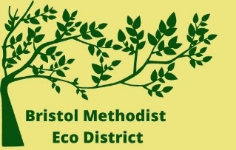
Facebook Group Don’t forget to visit our public Facebook group where you can share ideas, ask questions and discuss anything relating to the Bristol Eco District. You can visit the group by following this link: https://www.facebook.com/groups/526479268456099 or simply by searching for Bristol Methodist Eco District. The aim of this group is to share information and ideas to help our churches and individuals to live more sustainably. Please visit the group and join in discussion – it helps to spread the news of Eco Church across the District and further afield!
Please feel free to copy this newsletter or any parts you feel relevant to your situation and use it in church notices or magazines.

